基于xmpp openfire smack开发之Android客户端开发[3]

1.源码结构介绍
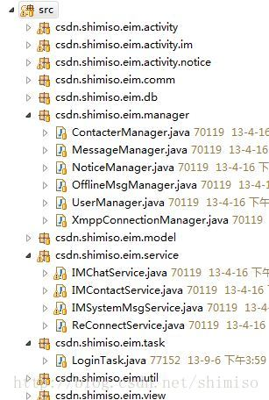
activity包下存放一些android页面交互相关的控制程序，还有一个些公共帮助类
db包为sqlite的工具类封装，这里做了一些自定义的改造，稍微仿Spring的JdbcTemplate结构，使用起来更加方便一点
manager包留下主要是一些管理组件，包括联系人管理，消息管理，提醒管理，离线消息管理，用户管理，xmpp连接管理
model包中都是一些对象模型，传输介质
service中存放一些android后台的核心服务，主要包括聊天服务，联系人服务，系统消息服务，重连接服务
task包中存放一些耗时的异步操作
util中存放一些常用的工具类
view中一些和android的UI相关的显示控件

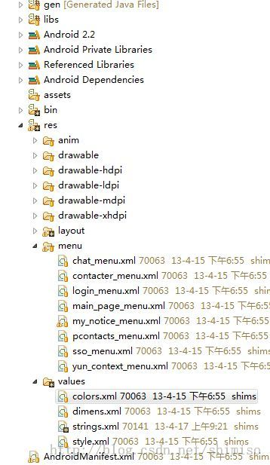
anim中存放一些动画元素的配置
layout是布局页面
menu是地步菜单布局页面
values中存放一些字符，颜色，样式，参数的配置信息
其中strings.xml中，保存的缺省配置为gtalk的服务器信息，大家如果有谷歌gtalk的账号可以直接登录，否则需要更改这里的配置才可以使用其他的xmpp服务器
[html] view plaincopy
- <!-- 缺省的服务器配置 -->
- <integer name="xmpp_port">5222</integer>
- <string name="xmpp_host">talk.google.com</string>
- <string name="xmpp_service_name">gmail.com</string>
- <bool name="is_remember">true</bool>
- <bool name="is_autologin">false</bool>
- <bool name="is_novisible">false</bool>
AndroidManifest.xml为android功能清单的配置文件，我们这里开放的权限并不多
[html] view plaincopy
- <!-- 访问Internet -->
- <uses-permission android:name="android.permission.INTERNET" />
- <!--- 访问网络状态 -->
- <uses-permission android:name="android.permission.ACCESS_NETWORK_STATE" />
- <!-- 往SDCard写入数据权限 -->
- <uses-permission android:name="android.permission.WRITE_EXTERNAL_STORAGE"/>
- <span style="WHITE-SPACE: pre"> </span><!-- 在SDCard中创建与删除文件权限 -->
- <span style="WHITE-SPACE: pre"> </span><uses-permission android:name="android.permission.MOUNT_UNMOUNT_FILESYSTEMS"/>
- <span style="WHITE-SPACE: pre"> </span><!-- 往SDCard写入数据权限 -->
- <span style="WHITE-SPACE: pre"> </span><uses-permission android:name="android.permission.WRITE_EXTERNAL_STORAGE"/>

2.核心类介绍
1.ActivitySupport类
[java] view plaincopy
- package csdn.shimiso.eim.activity;

- import android.app.Activity;
- import android.app.AlertDialog;
- import android.app.Notification;
- import android.app.NotificationManager;
- import android.app.PendingIntent;
- import android.app.ProgressDialog;
- import android.content.Context;
- import android.content.DialogInterface;
- import android.content.Intent;
- import android.content.SharedPreferences;
- import android.location.LocationManager;
- import android.net.ConnectivityManager;
- import android.net.NetworkInfo;
- import android.os.Bundle;
- import android.os.Environment;
- import android.provider.Settings;
- import android.view.inputmethod.InputMethodManager;
- import android.widget.Toast;
- import csdn.shimiso.eim.R;
- import csdn.shimiso.eim.comm.Constant;
- import csdn.shimiso.eim.model.LoginConfig;
- import csdn.shimiso.eim.service.IMChatService;
- import csdn.shimiso.eim.service.IMContactService;
- import csdn.shimiso.eim.service.IMSystemMsgService;
- import csdn.shimiso.eim.service.ReConnectService;

- /**
- * Actity 工具支持类
- *
- * @author shimiso
- *
- */
- public class ActivitySupport extends Activity implements IActivitySupport {

- protected Context context = null;
- protected SharedPreferences preferences;
- protected EimApplication eimApplication;
- protected ProgressDialog pg = null;
- protected NotificationManager notificationManager;

- @Override
- protected void onCreate(Bundle savedInstanceState) {
- super.onCreate(savedInstanceState);
- context = this;
- preferences = getSharedPreferences(Constant.LOGIN_SET, 0);
- notificationManager = (NotificationManager) getSystemService(NOTIFICATION_SERVICE);
- pg = new ProgressDialog(context);
- eimApplication = (EimApplication) getApplication();
- eimApplication.addActivity(this);
- }

- @Override
- protected void onStart() {
- super.onStart();
- }

- @Override
- protected void onResume() {
- super.onResume();
- }

- @Override
- protected void onPause() {
- super.onPause();
- }

- @Override
- protected void onStop() {
- super.onStop();
- }

- @Override
- public void onDestroy() {
- super.onDestroy();
- }

- @Override
- public ProgressDialog getProgressDialog() {
- return pg;
- }

- @Override
- public void startService() {
- // 好友联系人服务
- Intent server = new Intent(context, IMContactService.class);
- context.startService(server);
- // 聊天服务
- Intent chatServer = new Intent(context, IMChatService.class);
- context.startService(chatServer);
- // 自动恢复连接服务
- Intent reConnectService = new Intent(context, ReConnectService.class);
- context.startService(reConnectService);
- // 系统消息连接服务
- Intent imSystemMsgService = new Intent(context,
- IMSystemMsgService.class);
- context.startService(imSystemMsgService);
- }

- /**
- *
- * 销毁服务.
- *
- * @author shimiso
- * @update 2012-5-16 下午12:16:08
- */
- @Override
- public void stopService() {
- // 好友联系人服务
- Intent server = new Intent(context, IMContactService.class);
- context.stopService(server);
- // 聊天服务
- Intent chatServer = new Intent(context, IMChatService.class);
- context.stopService(chatServer);

- // 自动恢复连接服务
- Intent reConnectService = new Intent(context, ReConnectService.class);
- context.stopService(reConnectService);

- // 系统消息连接服务
- Intent imSystemMsgService = new Intent(context,
- IMSystemMsgService.class);
- context.stopService(imSystemMsgService);
- }

- @Override
- public void isExit() {
- new AlertDialog.Builder(context).setTitle("确定退出吗?")
- .setNeutralButton("确定", new DialogInterface.OnClickListener() {
- @Override
- public void onClick(DialogInterface dialog, int which) {
- stopService();
- eimApplication.exit();
- }
- })
- .setNegativeButton("取消", new DialogInterface.OnClickListener() {
- @Override
- public void onClick(DialogInterface dialog, int which) {
- dialog.cancel();
- }
- }).show();
- }

- @Override
- public boolean hasInternetConnected() {
- ConnectivityManager manager = (ConnectivityManager) context
- .getSystemService(context.CONNECTIVITY_SERVICE);
- if (manager != null) {
- NetworkInfo network = manager.getActiveNetworkInfo();
- if (network != null && network.isConnectedOrConnecting()) {
- return true;
- }
- }
- return false;
- }

- @Override
- public boolean validateInternet() {
- ConnectivityManager manager = (ConnectivityManager) context
- .getSystemService(context.CONNECTIVITY_SERVICE);
- if (manager == null) {
- openWirelessSet();
- return false;
- } else {
- NetworkInfo[] info = manager.getAllNetworkInfo();
- if (info != null) {
- for (int i = 0; i < info.length; i++) {
- if (info[i].getState() == NetworkInfo.State.CONNECTED) {
- return true;
- }
- }
- }
- }
- openWirelessSet();
- return false;
- }

- @Override
- public boolean hasLocationGPS() {
- LocationManager manager = (LocationManager) context
- .getSystemService(context.LOCATION_SERVICE);
- if (manager
- .isProviderEnabled(android.location.LocationManager.GPS_PROVIDER)) {
- return true;
- } else {
- return false;
- }
- }

- @Override
- public boolean hasLocationNetWork() {
- LocationManager manager = (LocationManager) context
- .getSystemService(context.LOCATION_SERVICE);
- if (manager
- .isProviderEnabled(android.location.LocationManager.NETWORK_PROVIDER)) {
- return true;
- } else {
- return false;
- }
- }

- @Override
- public void checkMemoryCard() {
- if (!Environment.MEDIA_MOUNTED.equals(Environment
- .getExternalStorageState())) {
- new AlertDialog.Builder(context)
- .setTitle(R.string.prompt)
- .setMessage("请检查内存卡")
- .setPositiveButton(R.string.menu_settings,
- new DialogInterface.OnClickListener() {
- @Override
- public void onClick(DialogInterface dialog,
- int which) {
- dialog.cancel();
- Intent intent = new Intent(
- Settings.ACTION_SETTINGS);
- context.startActivity(intent);
- }
- })
- .setNegativeButton("退出",
- new DialogInterface.OnClickListener() {
- @Override
- public void onClick(DialogInterface dialog,
- int which) {
- dialog.cancel();
- eimApplication.exit();
- }
- }).create().show();
- }
- }

- public void openWirelessSet() {
- AlertDialog.Builder dialogBuilder = new AlertDialog.Builder(context);
- dialogBuilder
- .setTitle(R.string.prompt)
- .setMessage(context.getString(R.string.check_connection))
- .setPositiveButton(R.string.menu_settings,
- new DialogInterface.OnClickListener() {
- @Override
- public void onClick(DialogInterface dialog,
- int which) {
- dialog.cancel();
- Intent intent = new Intent(
- Settings.ACTION_WIRELESS_SETTINGS);
- context.startActivity(intent);
- }
- })
- .setNegativeButton(R.string.close,
- new DialogInterface.OnClickListener() {
- @Override
- public void onClick(DialogInterface dialog,
- int whichButton) {
- dialog.cancel();
- }
- });
- dialogBuilder.show();
- }

- /**
- *
- * 显示toast
- *
- * @param text
- * @param longint
- * @author shimiso
- * @update 2012-6-28 下午3:46:18
- */
- public void showToast(String text, int longint) {
- Toast.makeText(context, text, longint).show();
- }

- @Override
- public void showToast(String text) {
- Toast.makeText(context, text, Toast.LENGTH_SHORT).show();
- }

- /**
- *
- * 关闭键盘事件
- *
- * @author shimiso
- * @update 2012-7-4 下午2:34:34
- */
- public void closeInput() {
- InputMethodManager inputMethodManager = (InputMethodManager) getSystemService(Context.INPUT_METHOD_SERVICE);
- if (inputMethodManager != null && this.getCurrentFocus() != null) {
- inputMethodManager.hideSoftInputFromWindow(this.getCurrentFocus()
- .getWindowToken(), InputMethodManager.HIDE_NOT_ALWAYS);
- }
- }

- /**
- *
- * 发出Notification的method.
- *
- * @param iconId
- * 图标
- * @param contentTitle
- * 标题
- * @param contentText
- * 你内容
- * @param activity
- * @author shimiso
- * @update 2012-5-14 下午12:01:55
- */
- public void setNotiType(int iconId, String contentTitle,
- String contentText, Class activity, String from) {
- /*
- * 创建新的Intent，作为点击Notification留言条时， 会运行的Activity
- */
- Intent notifyIntent = new Intent(this, activity);
- notifyIntent.putExtra("to", from);
- // notifyIntent.setFlags(Intent.FLAG_ACTIVITY_NEW_TASK);

- /* 创建PendingIntent作为设置递延运行的Activity */
- PendingIntent appIntent = PendingIntent.getActivity(this, 0,
- notifyIntent, 0);

- /* 创建Notication，并设置相关参数 */
- Notification myNoti = new Notification();
- // 点击自动消失
- myNoti.flags = Notification.FLAG_AUTO_CANCEL;
- /* 设置statusbar显示的icon */
- myNoti.icon = iconId;
- /* 设置statusbar显示的文字信息 */
- myNoti.tickerText = contentTitle;
- /* 设置notification发生时同时发出默认声音 */
- myNoti.defaults = Notification.DEFAULT_SOUND;
- /* 设置Notification留言条的参数 */
- myNoti.setLatestEventInfo(this, contentTitle, contentText, appIntent);
- /* 送出Notification */
- notificationManager.notify(0, myNoti);
- }

- @Override
- public Context getContext() {
- return context;
- }

- @Override
- public SharedPreferences getLoginUserSharedPre() {
- return preferences;
- }

- @Override
- public void saveLoginConfig(LoginConfig loginConfig) {
- preferences.edit()
- .putString(Constant.XMPP_HOST, loginConfig.getXmppHost())
- .commit();
- preferences.edit()
- .putInt(Constant.XMPP_PORT, loginConfig.getXmppPort()).commit();
- preferences
- .edit()
- .putString(Constant.XMPP_SEIVICE_NAME,
- loginConfig.getXmppServiceName()).commit();
- preferences.edit()
- .putString(Constant.USERNAME, loginConfig.getUsername())
- .commit();
- preferences.edit()
- .putString(Constant.PASSWORD, loginConfig.getPassword())
- .commit();
- preferences.edit()
- .putBoolean(Constant.IS_AUTOLOGIN, loginConfig.isAutoLogin())
- .commit();
- preferences.edit()
- .putBoolean(Constant.IS_NOVISIBLE, loginConfig.isNovisible())
- .commit();
- preferences.edit()
- .putBoolean(Constant.IS_REMEMBER, loginConfig.isRemember())
- .commit();
- preferences.edit()
- .putBoolean(Constant.IS_ONLINE, loginConfig.isOnline())
- .commit();
- preferences.edit()
- .putBoolean(Constant.IS_FIRSTSTART, loginConfig.isFirstStart())
- .commit();
- }

- @Override
- public LoginConfig getLoginConfig() {
- LoginConfig loginConfig = new LoginConfig();
- String a = preferences.getString(Constant.XMPP_HOST, null);
- String b = getResources().getString(R.string.xmpp_host);
- loginConfig.setXmppHost(preferences.getString(Constant.XMPP_HOST,
- getResources().getString(R.string.xmpp_host)));
- loginConfig.setXmppPort(preferences.getInt(Constant.XMPP_PORT,
- getResources().getInteger(R.integer.xmpp_port)));
- loginConfig.setUsername(preferences.getString(Constant.USERNAME, null));
- loginConfig.setPassword(preferences.getString(Constant.PASSWORD, null));
- loginConfig.setXmppServiceName(preferences.getString(
- Constant.XMPP_SEIVICE_NAME,
- getResources().getString(R.string.xmpp_service_name)));
- loginConfig.setAutoLogin(preferences.getBoolean(Constant.IS_AUTOLOGIN,
- getResources().getBoolean(R.bool.is_autologin)));
- loginConfig.setNovisible(preferences.getBoolean(Constant.IS_NOVISIBLE,
- getResources().getBoolean(R.bool.is_novisible)));
- loginConfig.setRemember(preferences.getBoolean(Constant.IS_REMEMBER,
- getResources().getBoolean(R.bool.is_remember)));
- loginConfig.setFirstStart(preferences.getBoolean(
- Constant.IS_FIRSTSTART, true));
- return loginConfig;
- }

- @Override
- public boolean getUserOnlineState() {
- // preferences = getSharedPreferences(Constant.LOGIN_SET,0);
- return preferences.getBoolean(Constant.IS_ONLINE, true);
- }

- @Override
- public void setUserOnlineState(boolean isOnline) {
- // preferences = getSharedPreferences(Constant.LOGIN_SET,0);
- preferences.edit().putBoolean(Constant.IS_ONLINE, isOnline).commit();

- }

- @Override
- public EimApplication getEimApplication() {
- return eimApplication;
- }
- }
大家写android程序会发现，不同的activity之间经常需要调用一些公共的资源，这里的资源不仅包括android自身的，还有我们自己的管理服务类，甚至相互之间传递一些参数，这里我仿照struts2的设计，提炼出一个ActivitySupport类，同时抽取一个接口，让所有的Activity都集成这个类，因为有了接口，我们便可以采用回调模式，非常方便的传递数据和使用公共的资源，这种好处相信大家使用之后都能有深刻的体会，通过接口回调传递参数和相互调用的方式无疑是最优雅的，spring和hibernate源码中曾经大量使用这种结构。

2.SQLiteTemplate类
[java] view plaincopy
- package csdn.shimiso.eim.db;

- import java.util.ArrayList;
- import java.util.List;

- import android.content.ContentValues;
- import android.database.Cursor;
- import android.database.sqlite.SQLiteDatabase;

- /**
- * SQLite数据库模板工具类
- *
- * 该类提供了数据库操作常用的增删改查,以及各种复杂条件匹配,分页,排序等操作
- *
- * @see SQLiteDatabase
- */
- public class SQLiteTemplate {
- /**
- * Default Primary key
- */
- protected String mPrimaryKey = "_id";

- /**
- * DBManager
- */
- private DBManager dBManager;
- /**
- * 是否为一个事务
- */
- private boolean isTransaction = false;
- /**
- * 数据库连接
- */
- private SQLiteDatabase dataBase = null;

- private SQLiteTemplate() {
- }

- private SQLiteTemplate(DBManager dBManager, boolean isTransaction) {
- this.dBManager = dBManager;
- this.isTransaction = isTransaction;
- }

- /**
- * isTransaction 是否属于一个事务 注:一旦isTransaction设为true
- * 所有的SQLiteTemplate方法都不会自动关闭资源,需在事务成功后手动关闭
- *
- * @return
- */
- public static SQLiteTemplate getInstance(DBManager dBManager,
- boolean isTransaction) {
- return new SQLiteTemplate(dBManager, isTransaction);
- }

- /**
- * 执行一条sql语句
- *
- * @param name
- * @param tel
- */
- public void execSQL(String sql) {
- try {
- dataBase = dBManager.openDatabase();
- dataBase.execSQL(sql);
- } catch (Exception e) {
- e.printStackTrace();
- } finally {
- if (!isTransaction) {
- closeDatabase(null);
- }
- }
- }

- /**
- * 执行一条sql语句
- *
- * @param name
- * @param tel
- */
- public void execSQL(String sql, Object[] bindArgs) {
- try {
- dataBase = dBManager.openDatabase();
- dataBase.execSQL(sql, bindArgs);
- } catch (Exception e) {
- e.printStackTrace();
- } finally {
- if (!isTransaction) {
- closeDatabase(null);
- }
- }
- }

- /**
- * 向数据库表中插入一条数据
- *
- * @param table
- * 表名
- * @param content
- * 字段值
- */
- public long insert(String table, ContentValues content) {
- try {
- dataBase = dBManager.openDatabase();
- // insert方法第一参数：数据库表名，第二个参数如果CONTENT为空时则向表中插入一个NULL,第三个参数为插入的内容
- return dataBase.insert(table, null, content);
- } catch (Exception e) {
- e.printStackTrace();
- } finally {
- if (!isTransaction) {
- closeDatabase(null);
- }
- }
- return 0;
- }

- /**
- * 批量删除指定主键数据
- *
- * @param ids
- */
- public void deleteByIds(String table, Object... primaryKeys) {
- try {
- if (primaryKeys.length > 0) {
- StringBuilder sb = new StringBuilder();
- for (@SuppressWarnings("unused")
- Object id : primaryKeys) {
- sb.append("?").append(",");
- }
- sb.deleteCharAt(sb.length() - 1);
- dataBase = dBManager.openDatabase();
- dataBase.execSQL("delete from " + table + " where "
- + mPrimaryKey + " in(" + sb + ")",
- (Object[]) primaryKeys);
- }
- } catch (Exception e) {
- e.printStackTrace();
- } finally {
- if (!isTransaction) {
- closeDatabase(null);
- }
- }
- }

- /**
- * 根据某一个字段和值删除一行数据, 如 name="jack"
- *
- * @param table
- * @param field
- * @param value
- * @return 返回值大于0表示删除成功
- */
- public int deleteByField(String table, String field, String value) {
- try {
- dataBase = dBManager.openDatabase();
- return dataBase.delete(table, field + "=?", new String[] { value });
- } catch (Exception e) {
- e.printStackTrace();
- } finally {
- if (!isTransaction) {
- closeDatabase(null);
- }
- }
- return 0;
- }

- /**
- * 根据条件删除数据
- *
- * @param table
- * 表名
- * @param whereClause
- * 查询语句 参数采用?
- * @param whereArgs
- * 参数值
- * @return 返回值大于0表示删除成功
- */
- public int deleteByCondition(String table, String whereClause,
- String[] whereArgs) {
- try {
- dataBase = dBManager.openDatabase();
- return dataBase.delete(table, whereClause, whereArgs);
- } catch (Exception e) {
- e.printStackTrace();
- } finally {
- if (!isTransaction) {
- closeDatabase(null);
- }
- }
- return 0;
- }

- /**
- * 根据主键删除一行数据
- *
- * @param table
- * @param id
- * @return 返回值大于0表示删除成功
- */
- public int deleteById(String table, String id) {
- try {
- dataBase = dBManager.openDatabase();
- return deleteByField(table, mPrimaryKey, id);
- } catch (Exception e) {
- e.printStackTrace();
- } finally {
- if (!isTransaction) {
- closeDatabase(null);
- }
- }
- return 0;
- }

- /**
- * 根据主键更新一行数据
- *
- * @param table
- * @param id
- * @param values
- * @return 返回值大于0表示更新成功
- */
- public int updateById(String table, String id, ContentValues values) {
- try {
- dataBase = dBManager.openDatabase();
- return dataBase.update(table, values, mPrimaryKey + "=?",
- new String[] { id });
- } catch (Exception e) {
- e.printStackTrace();
- } finally {
- if (!isTransaction) {
- closeDatabase(null);
- }
- }
- return 0;
- }

- /**
- * 更新数据
- *
- * @param table
- * @param values
- * @param whereClause
- * @param whereArgs
- * @return 返回值大于0表示更新成功
- */
- public int update(String table, ContentValues values, String whereClause,
- String[] whereArgs) {
- try {
- dataBase = dBManager.openDatabase();
- return dataBase.update(table, values, whereClause, whereArgs);
- } catch (Exception e) {
- e.printStackTrace();
- } finally {
- if (!isTransaction) {
- closeDatabase(null);
- }
- }
- return 0;
- }

- /**
- * 根据主键查看某条数据是否存在
- *
- * @param table
- * @param id
- * @return
- */
- public Boolean isExistsById(String table, String id) {
- try {
- dataBase = dBManager.openDatabase();
- return isExistsByField(table, mPrimaryKey, id);
- } catch (Exception e) {
- e.printStackTrace();
- } finally {
- if (!isTransaction) {
- closeDatabase(null);
- }
- }
- return null;
- }

- /**
- * 根据某字段/值查看某条数据是否存在
- *
- * @param status
- * @return
- */
- public Boolean isExistsByField(String table, String field, String value) {
- StringBuilder sql = new StringBuilder();
- sql.append("SELECT COUNT(*) FROM ").append(table).append(" WHERE ")
- .append(field).append(" =?");
- try {
- dataBase = dBManager.openDatabase();
- return isExistsBySQL(sql.toString(), new String[] { value });
- } catch (Exception e) {
- e.printStackTrace();
- } finally {
- if (!isTransaction) {
- closeDatabase(null);
- }
- }
- return null;
- }

- /**
- * 使用SQL语句查看某条数据是否存在
- *
- * @param sql
- * @param selectionArgs
- * @return
- */
- public Boolean isExistsBySQL(String sql, String[] selectionArgs) {
- Cursor cursor = null;
- try {
- dataBase = dBManager.openDatabase();
- cursor = dataBase.rawQuery(sql, selectionArgs);
- if (cursor.moveToFirst()) {
- return (cursor.getInt(0) > 0);
- } else {
- return false;
- }
- } catch (Exception e) {
- e.printStackTrace();
- } finally {
- if (!isTransaction) {
- closeDatabase(cursor);
- }
- }
- return null;
- }

- /**
- * 查询一条数据
- *
- * @param rowMapper
- * @param sql
- * @param args
- * @return
- */
- public <T> T queryForObject(RowMapper<T> rowMapper, String sql,
- String[] args) {
- Cursor cursor = null;
- T object = null;
- try {
- dataBase = dBManager.openDatabase();
- cursor = dataBase.rawQuery(sql, args);
- if (cursor.moveToFirst()) {
- object = rowMapper.mapRow(cursor, cursor.getCount());
- }
- } finally {
- if (!isTransaction) {
- closeDatabase(cursor);
- }
- }
- return object;

- }

- /**
- * 查询
- *
- * @param rowMapper
- * @param sql
- * @param startResult
- * 开始索引 注:第一条记录索引为0
- * @param maxResult
- * 步长
- * @return
- */
- public <T> List<T> queryForList(RowMapper<T> rowMapper, String sql,
- String[] selectionArgs) {
- Cursor cursor = null;
- List<T> list = null;
- try {
- dataBase = dBManager.openDatabase();
- cursor = dataBase.rawQuery(sql, selectionArgs);
- list = new ArrayList<T>();
- while (cursor.moveToNext()) {
- list.add(rowMapper.mapRow(cursor, cursor.getPosition()));
- }
- } finally {
- if (!isTransaction) {
- closeDatabase(cursor);
- }
- }
- return list;
- }

- /**
- * 分页查询
- *
- * @param rowMapper
- * @param sql
- * @param startResult
- * 开始索引 注:第一条记录索引为0
- * @param maxResult
- * 步长
- * @return
- */
- public <T> List<T> queryForList(RowMapper<T> rowMapper, String sql,
- int startResult, int maxResult) {
- Cursor cursor = null;
- List<T> list = null;
- try {
- dataBase = dBManager.openDatabase();
- cursor = dataBase.rawQuery(sql + " limit ?,?", new String[] {
- String.valueOf(startResult), String.valueOf(maxResult) });
- list = new ArrayList<T>();
- while (cursor.moveToNext()) {
- list.add(rowMapper.mapRow(cursor, cursor.getPosition()));
- }
- } finally {
- if (!isTransaction) {
- closeDatabase(cursor);
- }
- }
- return list;
- }

- /**
- * 获取记录数
- *
- * @return
- */
- public Integer getCount(String sql, String[] args) {
- Cursor cursor = null;
- try {
- dataBase = dBManager.openDatabase();
- cursor = dataBase.rawQuery("select count(*) from (" + sql + ")",
- args);
- if (cursor.moveToNext()) {
- return cursor.getInt(0);
- }
- } catch (Exception e) {
- e.printStackTrace();
- } finally {
- if (!isTransaction) {
- closeDatabase(cursor);
- }
- }
- return 0;
- }

- /**
- * 分页查询
- *
- * @param rowMapper
- * @param table
- * 检索的表
- * @param columns
- * 由需要返回列的列名所组成的字符串数组，传入null会返回所有的列。
- * @param selection
- * 查询条件子句，相当于select语句where关键字后面的部分，在条件子句允许使用占位符"?"
- * @param selectionArgs
- * 对应于selection语句中占位符的值，值在数组中的位置与占位符在语句中的位置必须一致，否则就会有异常
- * @param groupBy
- * 对结果集进行分组的group by语句（不包括GROUP BY关键字）。传入null将不对结果集进行分组
- * @param having
- * 对查询后的结果集进行过滤,传入null则不过滤
- * @param orderBy
- * 对结果集进行排序的order by语句（不包括ORDER BY关键字）。传入null将对结果集使用默认的排序
- * @param limit
- * 指定偏移量和获取的记录数，相当于select语句limit关键字后面的部分,如果为null则返回所有行
- * @return
- */
- public <T> List<T> queryForList(RowMapper<T> rowMapper, String table,
- String[] columns, String selection, String[] selectionArgs,
- String groupBy, String having, String orderBy, String limit) {
- List<T> list = null;
- Cursor cursor = null;
- try {
- dataBase = dBManager.openDatabase();
- cursor = dataBase.query(table, columns, selection, selectionArgs,
- groupBy, having, orderBy, limit);
- list = new ArrayList<T>();
- while (cursor.moveToNext()) {
- list.add(rowMapper.mapRow(cursor, cursor.getPosition()));
- }
- } finally {
- if (!isTransaction) {
- closeDatabase(cursor);
- }
- }
- return list;
- }

- /**
- * Get Primary Key
- *
- * @return
- */
- public String getPrimaryKey() {
- return mPrimaryKey;
- }

- /**
- * Set Primary Key
- *
- * @param primaryKey
- */
- public void setPrimaryKey(String primaryKey) {
- this.mPrimaryKey = primaryKey;
- }

- /**
- *
- * @author shimiso
- *
- * @param <T>
- */
- public interface RowMapper<T> {
- /**
- *
- * @param cursor
- * 游标
- * @param index
- * 下标索引
- * @return
- */
- public T mapRow(Cursor cursor, int index);
- }

- /**
- * 关闭数据库
- */
- public void closeDatabase(Cursor cursor) {
- if (null != dataBase) {
- dataBase.close();
- }
- if (null != cursor) {
- cursor.close();
- }
- }
- }

我们希望在android操作数据库是优雅的一种方式，这里不必关注事务，也不用担心分页，更不用为了封装传递对象烦恼，总之一切就像面向对象那样，简单，模板类的出现正是解决这个问题，虽然它看上去可能不是那么完美有待提高，这里我封装了很多sqlite常用的工具，大家可以借鉴使用。

3.XmppConnectionManager管理类
[java] view plaincopy
- package csdn.shimiso.eim.manager;

- import org.jivesoftware.smack.Connection;
- import org.jivesoftware.smack.ConnectionConfiguration;
- import org.jivesoftware.smack.Roster;
- import org.jivesoftware.smack.XMPPConnection;
- import org.jivesoftware.smack.provider.ProviderManager;
- import org.jivesoftware.smackx.GroupChatInvitation;
- import org.jivesoftware.smackx.PrivateDataManager;
- import org.jivesoftware.smackx.packet.ChatStateExtension;
- import org.jivesoftware.smackx.packet.LastActivity;
- import org.jivesoftware.smackx.packet.OfflineMessageInfo;
- import org.jivesoftware.smackx.packet.OfflineMessageRequest;
- import org.jivesoftware.smackx.packet.SharedGroupsInfo;
- import org.jivesoftware.smackx.provider.DataFormProvider;
- import org.jivesoftware.smackx.provider.DelayInformationProvider;
- import org.jivesoftware.smackx.provider.DiscoverInfoProvider;
- import org.jivesoftware.smackx.provider.DiscoverItemsProvider;
- import org.jivesoftware.smackx.provider.MUCAdminProvider;
- import org.jivesoftware.smackx.provider.MUCOwnerProvider;
- import org.jivesoftware.smackx.provider.MUCUserProvider;
- import org.jivesoftware.smackx.provider.MessageEventProvider;
- import org.jivesoftware.smackx.provider.MultipleAddressesProvider;
- import org.jivesoftware.smackx.provider.RosterExchangeProvider;
- import org.jivesoftware.smackx.provider.StreamInitiationProvider;
- import org.jivesoftware.smackx.provider.VCardProvider;
- import org.jivesoftware.smackx.provider.XHTMLExtensionProvider;
- import org.jivesoftware.smackx.search.UserSearch;

- import csdn.shimiso.eim.model.LoginConfig;

- /**
- *
- * XMPP服务器连接工具类.
- *
- * @author shimiso
- */
- public class XmppConnectionManager {
- private XMPPConnection connection;
- private static ConnectionConfiguration connectionConfig;
- private static XmppConnectionManager xmppConnectionManager;

- private XmppConnectionManager() {

- }

- public static XmppConnectionManager getInstance() {
- if (xmppConnectionManager == null) {
- xmppConnectionManager = new XmppConnectionManager();
- }
- return xmppConnectionManager;
- }

- // init
- public XMPPConnection init(LoginConfig loginConfig) {
- Connection.DEBUG_ENABLED = false;
- ProviderManager pm = ProviderManager.getInstance();
- configure(pm);

- connectionConfig = new ConnectionConfiguration(
- loginConfig.getXmppHost(), loginConfig.getXmppPort(),
- loginConfig.getXmppServiceName());
- connectionConfig.setSASLAuthenticationEnabled(false);// 不使用SASL验证，设置为false
- connectionConfig
- .setSecurityMode(ConnectionConfiguration.SecurityMode.enabled);
- // 允许自动连接
- connectionConfig.setReconnectionAllowed(false);
- // 允许登陆成功后更新在线状态
- connectionConfig.setSendPresence(true);
- // 收到好友邀请后manual表示需要经过同意,accept_all表示不经同意自动为好友
- Roster.setDefaultSubscriptionMode(Roster.SubscriptionMode.manual);
- connection = new XMPPConnection(connectionConfig);
- return connection;
- }

- /**
- *
- * 返回一个有效的xmpp连接,如果无效则返回空.
- *
- * @return
- * @author shimiso
- * @update 2012-7-4 下午6:54:31
- */
- public XMPPConnection getConnection() {
- if (connection == null) {
- throw new RuntimeException("请先初始化XMPPConnection连接");
- }
- return connection;
- }

- /**
- *
- * 销毁xmpp连接.
- *
- * @author shimiso
- * @update 2012-7-4 下午6:55:03
- */
- public void disconnect() {
- if (connection != null) {
- connection.disconnect();
- }
- }

- public void configure(ProviderManager pm) {

- // Private Data Storage
- pm.addIQProvider("query", "jabber:iq:private",
- new PrivateDataManager.PrivateDataIQProvider());

- // Time
- try {
- pm.addIQProvider("query", "jabber:iq:time",
- Class.forName("org.jivesoftware.smackx.packet.Time"));
- } catch (ClassNotFoundException e) {
- }

- // XHTML
- pm.addExtensionProvider("html", "http://jabber.org/protocol/xhtml-im",
- new XHTMLExtensionProvider());

- // Roster Exchange
- pm.addExtensionProvider("x", "jabber:x:roster",
- new RosterExchangeProvider());
- // Message Events
- pm.addExtensionProvider("x", "jabber:x:event",
- new MessageEventProvider());
- // Chat State
- pm.addExtensionProvider("active",
- "http://jabber.org/protocol/chatstates",
- new ChatStateExtension.Provider());
- pm.addExtensionProvider("composing",
- "http://jabber.org/protocol/chatstates",
- new ChatStateExtension.Provider());
- pm.addExtensionProvider("paused",
- "http://jabber.org/protocol/chatstates",
- new ChatStateExtension.Provider());
- pm.addExtensionProvider("inactive",
- "http://jabber.org/protocol/chatstates",
- new ChatStateExtension.Provider());
- pm.addExtensionProvider("gone",
- "http://jabber.org/protocol/chatstates",
- new ChatStateExtension.Provider());

- // FileTransfer
- pm.addIQProvider("si", "http://jabber.org/protocol/si",
- new StreamInitiationProvider());

- // Group Chat Invitations
- pm.addExtensionProvider("x", "jabber:x:conference",
- new GroupChatInvitation.Provider());
- // Service Discovery # Items
- pm.addIQProvider("query", "http://jabber.org/protocol/disco#items",
- new DiscoverItemsProvider());
- // Service Discovery # Info
- pm.addIQProvider("query", "http://jabber.org/protocol/disco#info",
- new DiscoverInfoProvider());
- // Data Forms
- pm.addExtensionProvider("x", "jabber:x:data", new DataFormProvider());
- // MUC User
- pm.addExtensionProvider("x", "http://jabber.org/protocol/muc#user",
- new MUCUserProvider());
- // MUC Admin
- pm.addIQProvider("query", "http://jabber.org/protocol/muc#admin",
- new MUCAdminProvider());
- // MUC Owner
- pm.addIQProvider("query", "http://jabber.org/protocol/muc#owner",
- new MUCOwnerProvider());
- // Delayed Delivery
- pm.addExtensionProvider("x", "jabber:x:delay",
- new DelayInformationProvider());
- // Version
- try {
- pm.addIQProvider("query", "jabber:iq:version",
- Class.forName("org.jivesoftware.smackx.packet.Version"));
- } catch (ClassNotFoundException e) {
- }
- // VCard
- pm.addIQProvider("vCard", "vcard-temp", new VCardProvider());
- // Offline Message Requests
- pm.addIQProvider("offline", "http://jabber.org/protocol/offline",
- new OfflineMessageRequest.Provider());
- // Offline Message Indicator
- pm.addExtensionProvider("offline",
- "http://jabber.org/protocol/offline",
- new OfflineMessageInfo.Provider());
- // Last Activity
- pm.addIQProvider("query", "jabber:iq:last", new LastActivity.Provider());
- // User Search
- pm.addIQProvider("query", "jabber:iq:search", new UserSearch.Provider());
- // SharedGroupsInfo
- pm.addIQProvider("sharedgroup",
- "http://www.jivesoftware.org/protocol/sharedgroup",
- new SharedGroupsInfo.Provider());
- // JEP-33: Extended Stanza Addressing
- pm.addExtensionProvider("addresses",
- "http://jabber.org/protocol/address",
- new MultipleAddressesProvider());

- }
- }
这个类是xmpp连接的管理类，如果大家使用smack的api对这个应该不会陌生，asmack对xmpp连接的管理，与smack的差别不大，但是部分细微区别也有，我们在使用中如果遇到问题，还要多加注意，我们这里将其设计成单例，毕竟重复创建连接是个非常消耗的过程。

3.演示效果

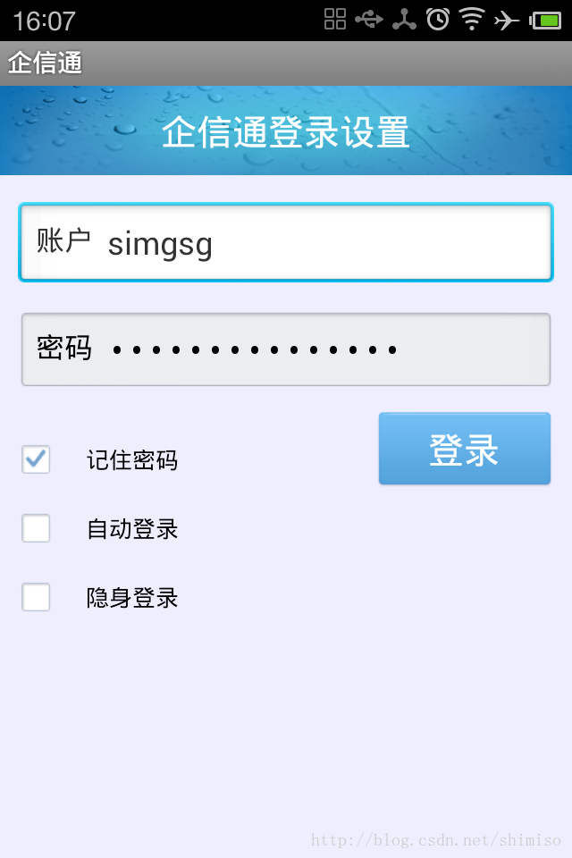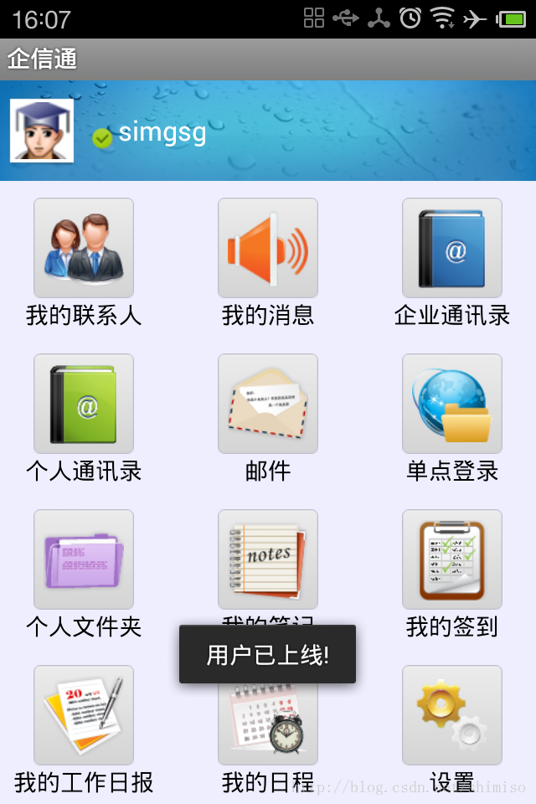

很像QQ吧，没错，这是2012年版本qq的安卓界面，只是界面元素一样，实现方式大不相同，下面简单列一下这个客户端实现的功能：
1.聊天
2.离线消息
3.添加，删除好友
4.添加，移动好友分组
5.设置昵称
6.监控好友状态
7.网络断开系统自动重连接
8.收到添加好友请求消息处理
9.收到系统广播消息处理
10.查看历史聊天记录
11.消息弹出提醒，和小气泡
....

